**GODADDY SOCIAL MEDIA ANALYTICS**

Duration: **1st Jan'19** to **23rd Sep'22**

Number of tweets analyzed: **452583**

Count of tweets:

Positive tweets (**202165**)

Negative tweets (**41754**)

Neutral tweets (**208664**)

Sentiment Analysis plots for Full data are:

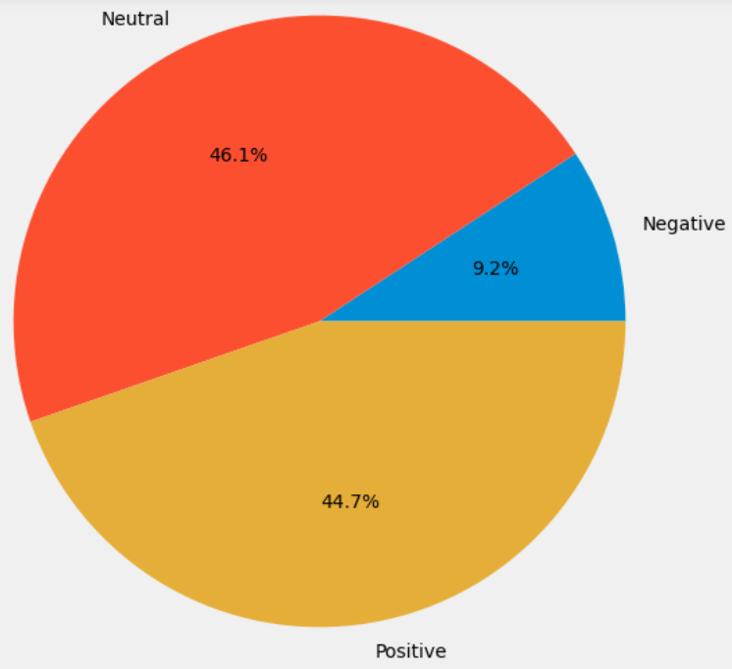

**Neutral Sentiment dominates, followed by Positive Sentiment.**

**Year wise Segregations:**

**YEAR: 2019**

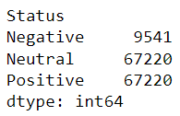

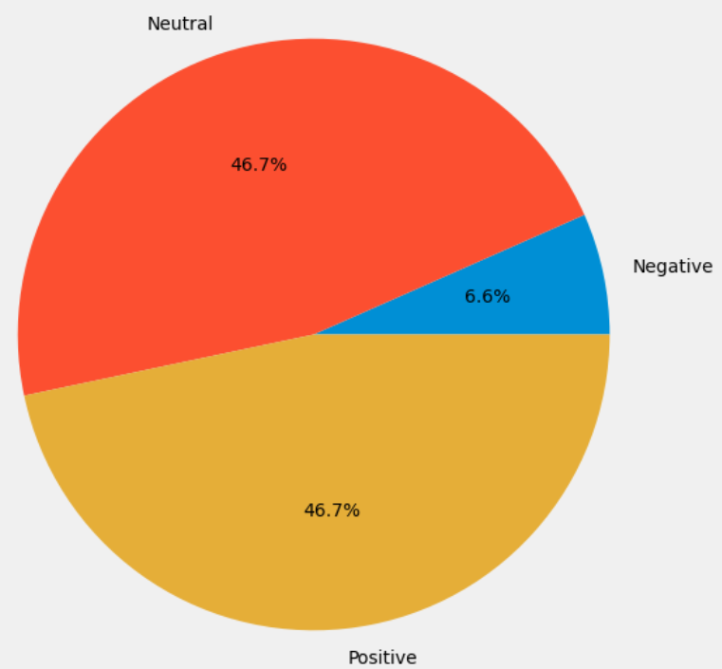

**YEAR 2020**

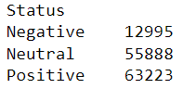

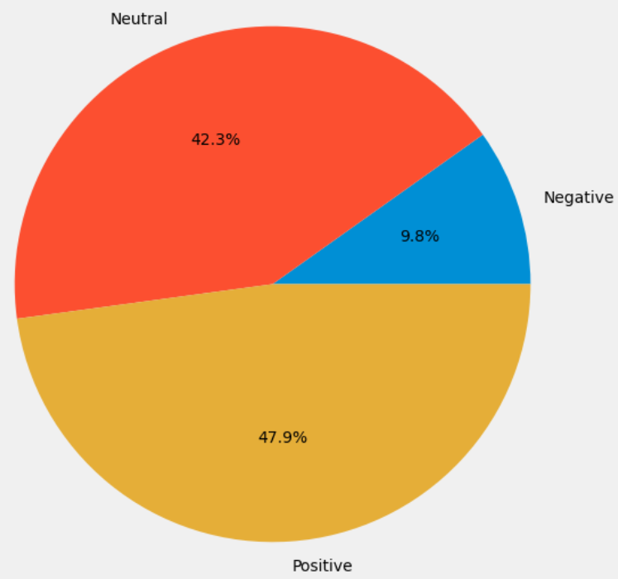

**YEAR 2021**

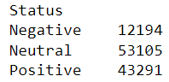

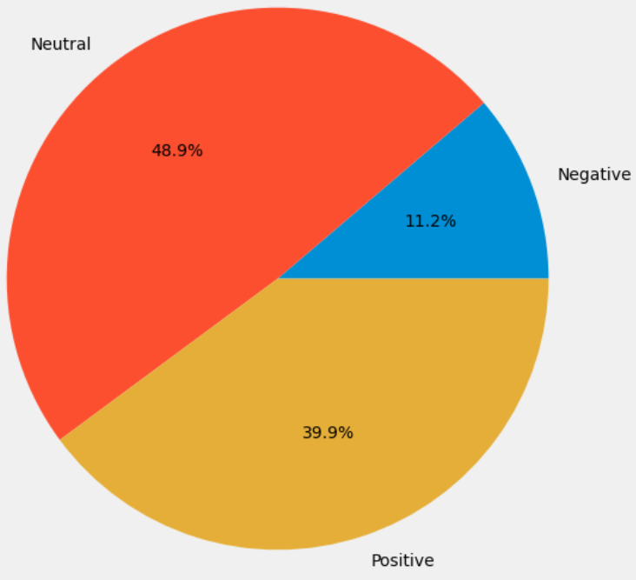

**YEAR 2022**

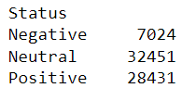

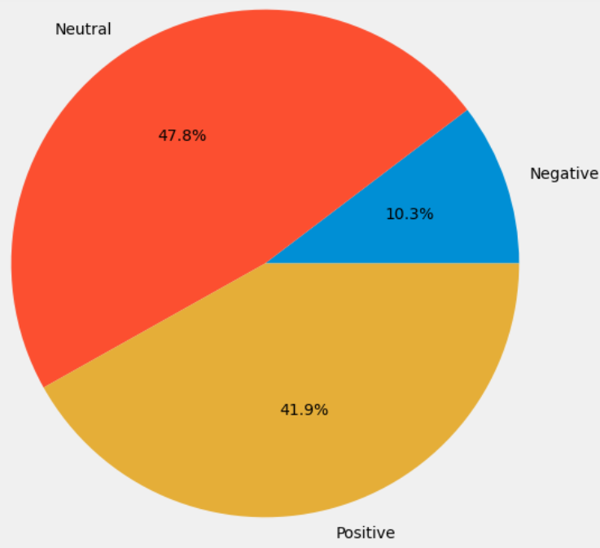

**Word Cloud plots for Positive, Negative & Neutral tweets:**

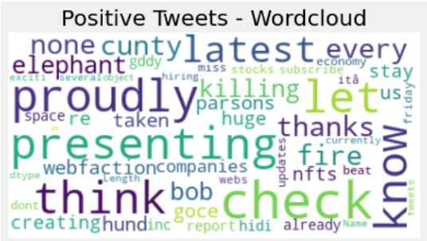

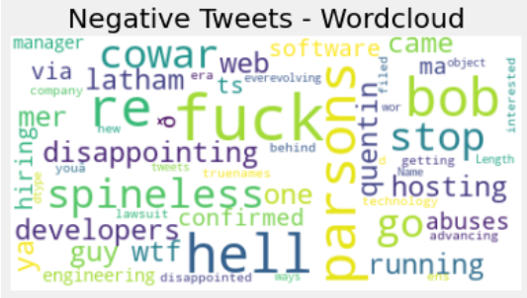

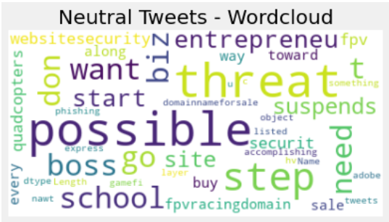

**Some of the most trending SERVICE related keywords identified:**

**builder**

**website**

**hosting**

**software**

**security**

**page**

**web**

**domain**

**email**

**wordpress**

**support**

**site**

**domain**

**service**

**subscribe**

**Sentiment Analysis of Tweets containing trending Service keywords taken separately:**

**BUILDER**

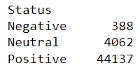

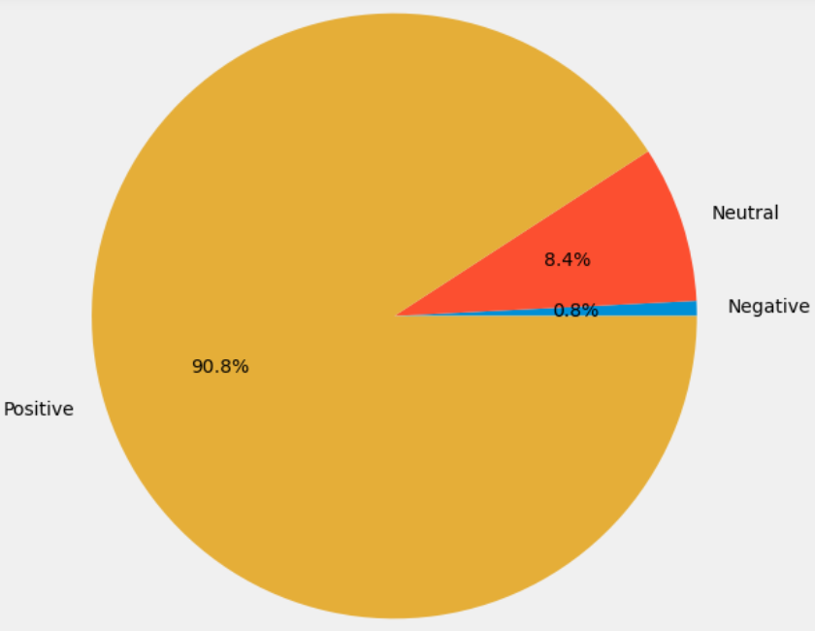

**WEBSITE**

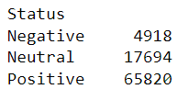

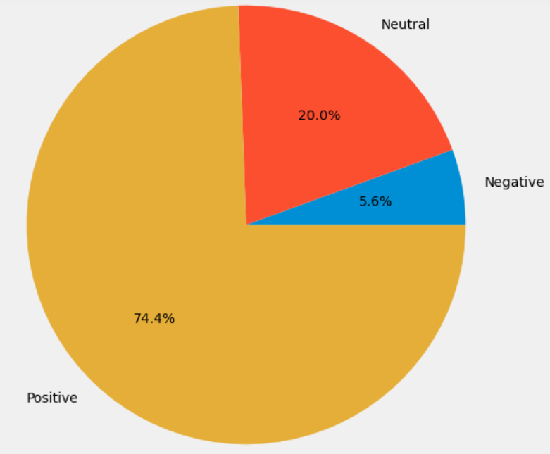

**HOSTING**

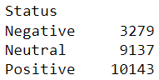

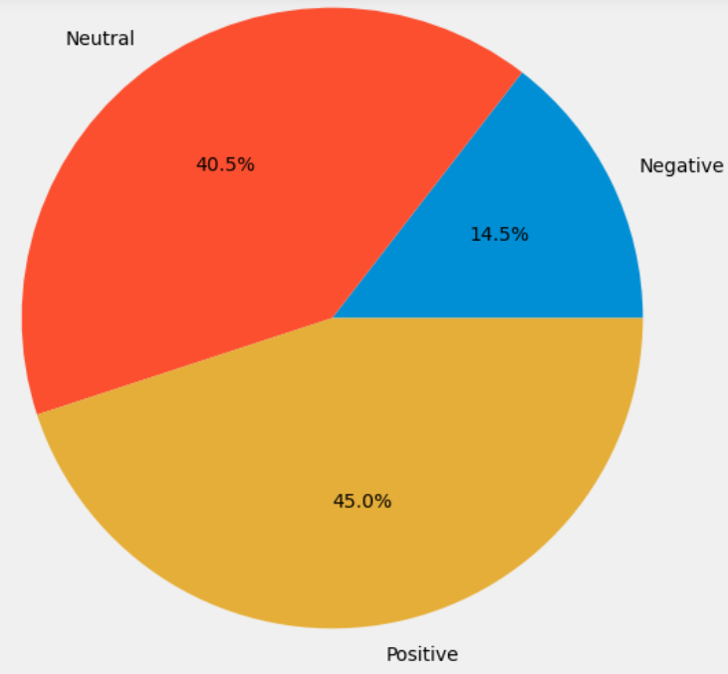

**SOFTWARE**

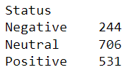

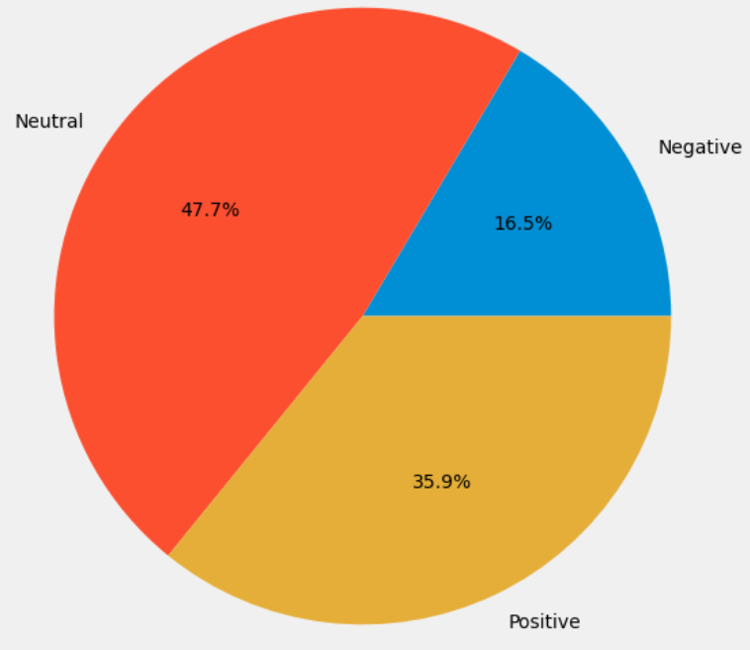

**SECURITY**

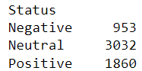

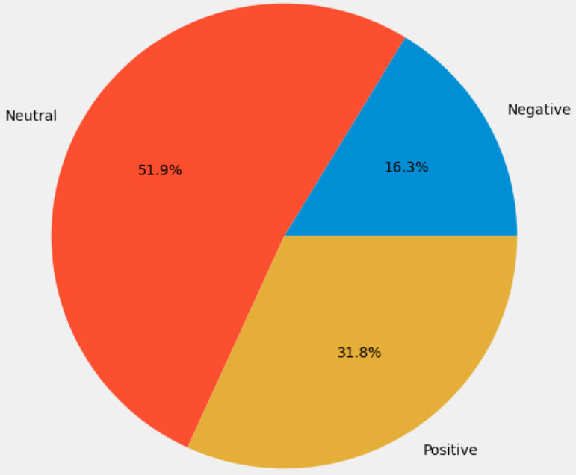

**PAGE**

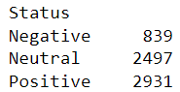

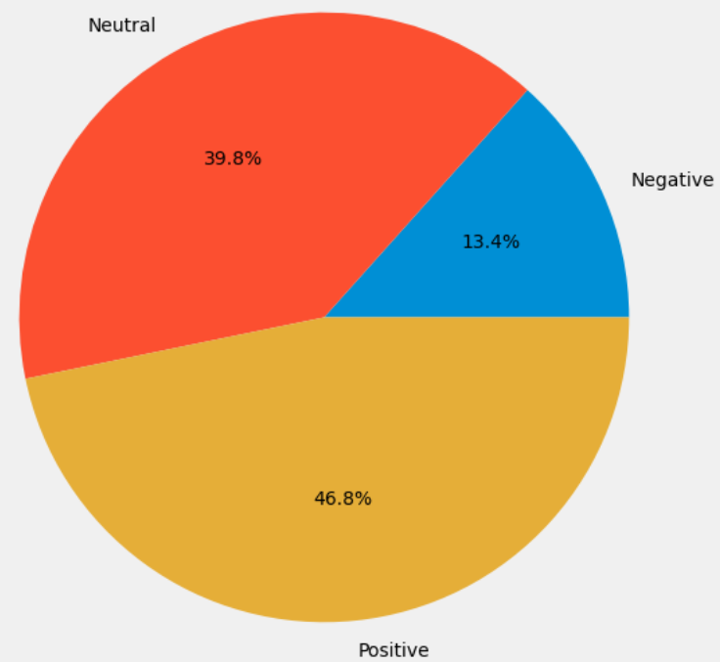

**WEB**

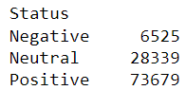

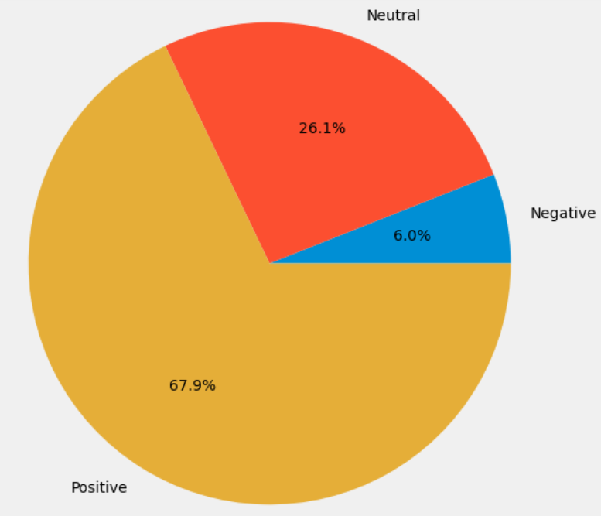

**DOMAIN**

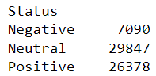

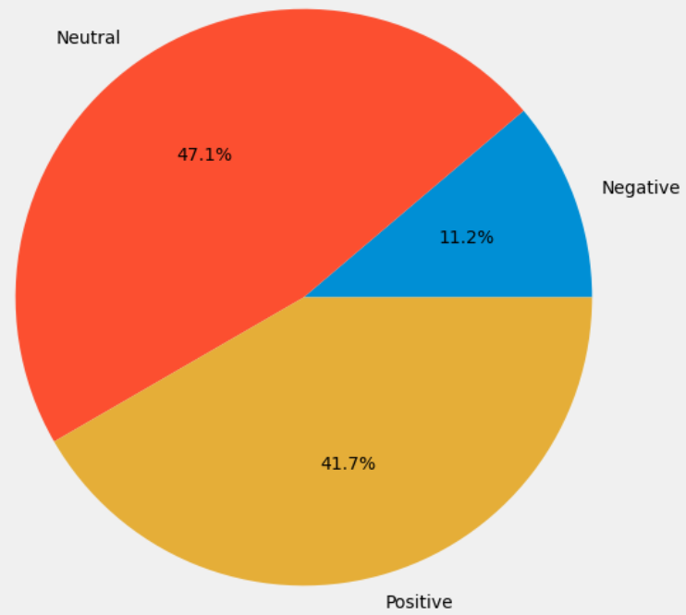

**EMAIL**

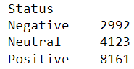

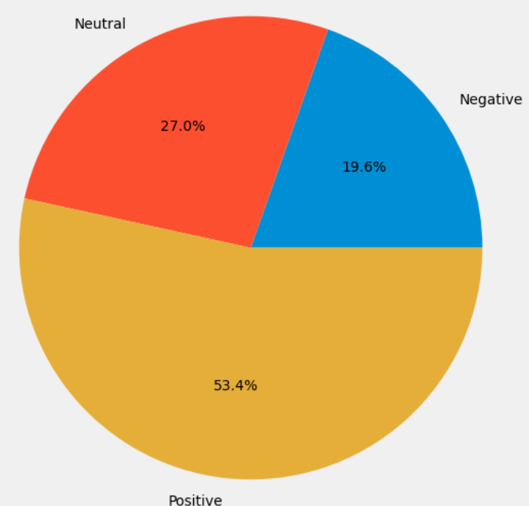

**WORDPRESS**

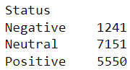

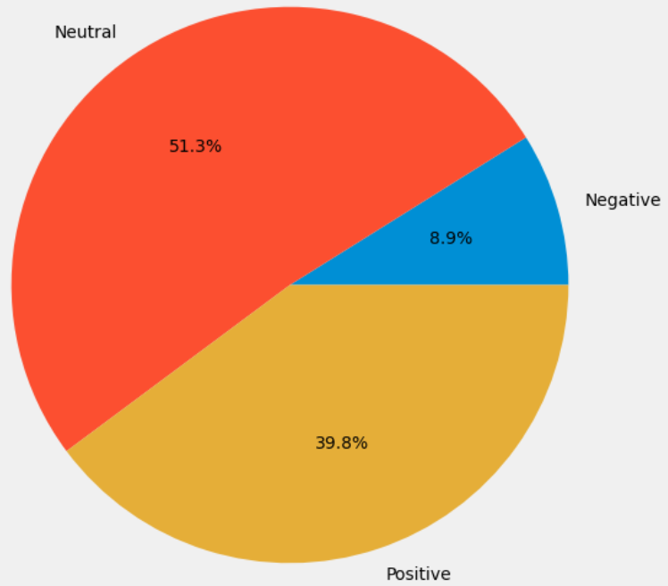

**SUPPORT**

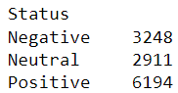

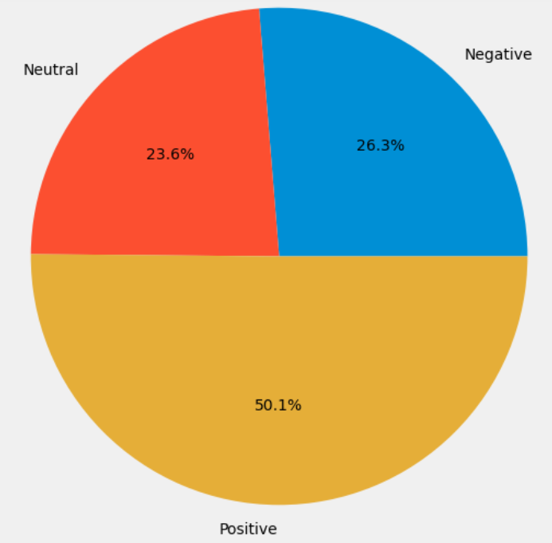

**SITE**

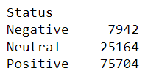

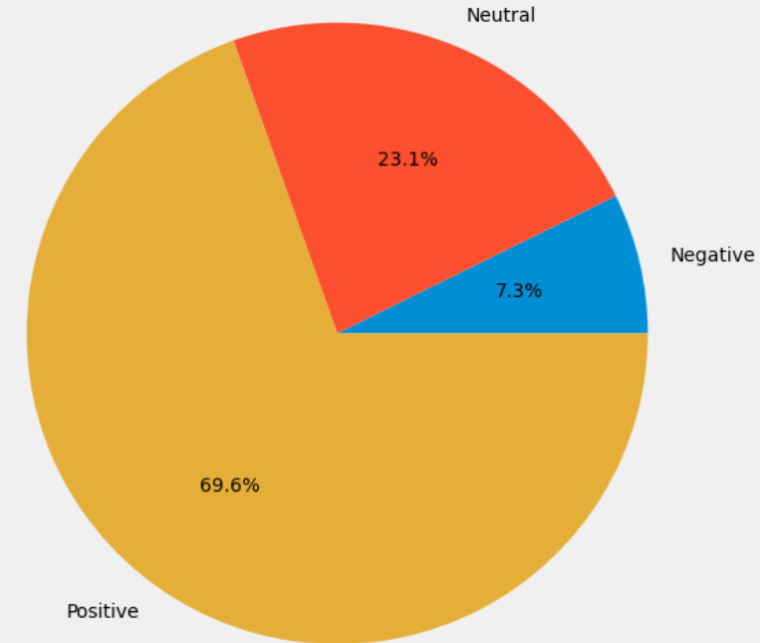

**SERVICE**

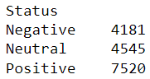

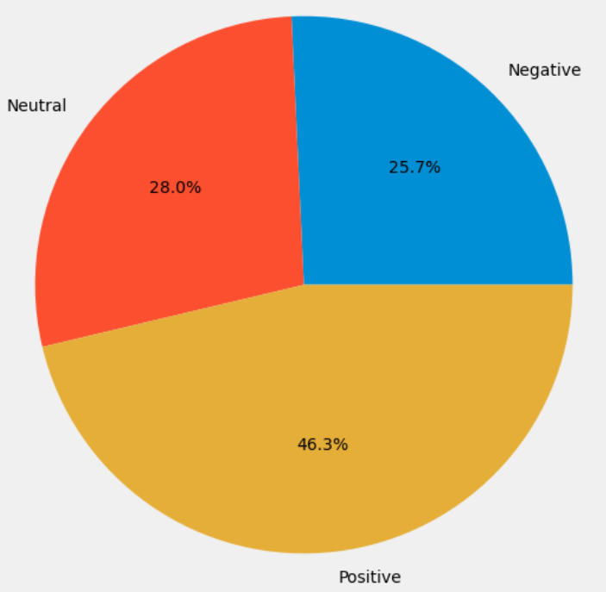

**SUBSCRIBE**

